Customer Activation & Retention

**INTRODUCTION**

Customer retention is a business’s ability to keep existing customers and continue to generate revenue from them. Companies use different tactics to convert first-time buyers into repeat shoppers. In other words, customer retention allows a business to increase the profitability of an existing customer and maximize their lifetime value.

Customer activation strategy involves detailed planning to motivate existing customers to proceed to the next level of their lifecycle faster. It can be for an existing active customer, a dormant customer, customer turning into an advocate, or also for a one-time customer that recently turned into a frequent user. There are times when customers will move through these stages by themselves. Even so, Customer Activation makes the process faster.

**Conceptual Background of the Domain Problem Customer**

Customer satisfaction has emerged as one of the most important factors that guarantee the success of online store; it has been posited as a key stimulant of purchase, repurchase intentions and customer loyalty. A comprehensive review of the literature, theories and models have been carried out to propose the models for customer activation and customer retention. Five major factors that contributed to the success of an e-commerce store have been identified as: service quality, system quality, information quality, trust and net benefit. The research furthermore investigated the factors that influence the online customers repeat purchase intention. The combination of both utilitarian value and hedonistic values are needed to affect the repeat purchase intention (loyalty) positively. The data is collected from the Indian online shoppers. Results indicate the e-retail success factors, which are very much critical for customer satisfaction.

**IMPORTANCE OF CUSTOMER RETENTION**

To begin with, to acquire a customer a company incurs promotional costs like advertising, sales promotion etc. It is said that it costs five times more to attract a new customer than retaining one. The operating cost decrease when a customer stays. Service being rich in experience and credence qualities, it takes some time for customers to get accustomed to it and once they are used to the service and are satisfied with the service provider, they tend to purchase more over a period of time. As they remain satisfied with a service provider, they spread a positive word of mouth, which is very effective in case of service for attracting new customers. Longer the customer stays with an organization, more the organization knows about him, which enables it to offer a customized service which makes it difficult for the customer to defect. This may even provide opportunities to the organization to charge price premium by offering individualized service which may be difficult for the competitors to offer. Considering the importance of retaining customers in service business, Reichheld & Sasser coined a term ‘Zero Defection’. They highlighted that companies can boost profits by almost 100% by retaining just 5% more of their customers. Further, it is also very important to understand the life time value of a customer. Further, if by a positive word of mouth, he brings just one more customer to the organization, his value to the organization doubles. Therefore, it is important for all the employees in the organization to understand the life time value of their customers.

**Customer Retention Benefits**

While most companies traditionally spend more money on customer acquisition because they view it as a quick and effective way of increasing revenue, customer retention often is faster and, on average, costs up to seven times less than customer acquisition. Selling to customers with whom you already have a relationship is often a more effective way of growing revenue because companies don’t need to attract, educate, and convert new ones.

**Data Analysis**

Current dataset is raw data. By proper Data Transformation methods, a lot of valuable insights can be gained. Also, we need to convert categorical info into numerical data type.

We need to obtain Site rating, Service rating, customer rating, Time spent by users on each platform, % of users using the platform, % of users recommending the platform for each platform, order cancellation possibility, Drawbacks of the platform, Success rate of user recommending the platform after used, % of potential risk, % of users recommending the platform after using the platform for longest time & % of users recommending the platform after being the most frequent buyer of the platform.

According to the period of usage, we also need to obtain insights about every platform. So that we can compare the customers retention rate of minimum and maximum period of usage.

Lastly, if a user has used all the platforms, then what are his views and recommendations regarding the platforms.

**Flow Chart for data transformation**

**Platform Attributes**

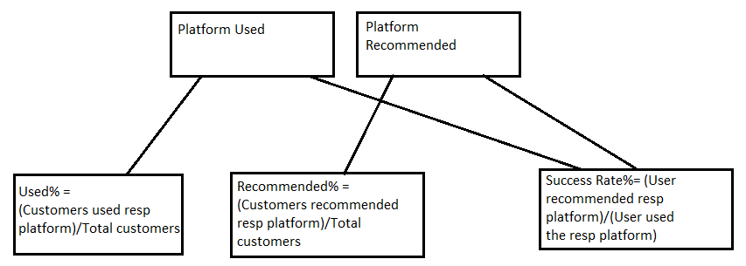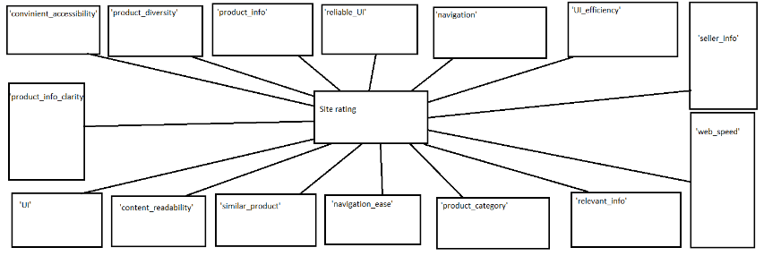

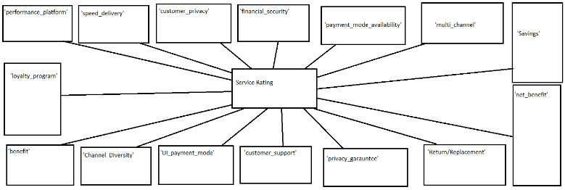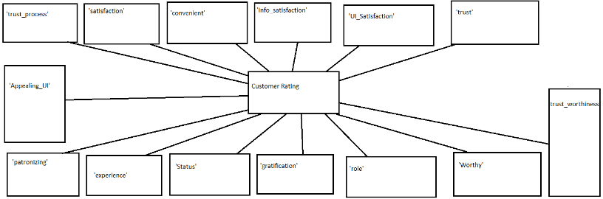

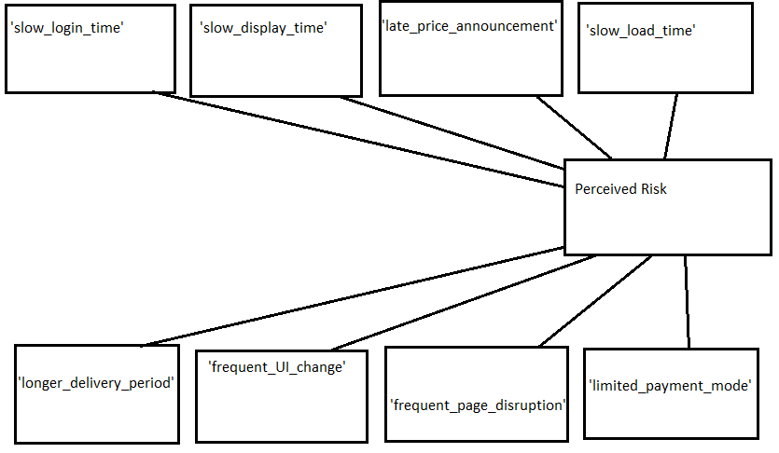

Upon more transforming of data, we get the below data.

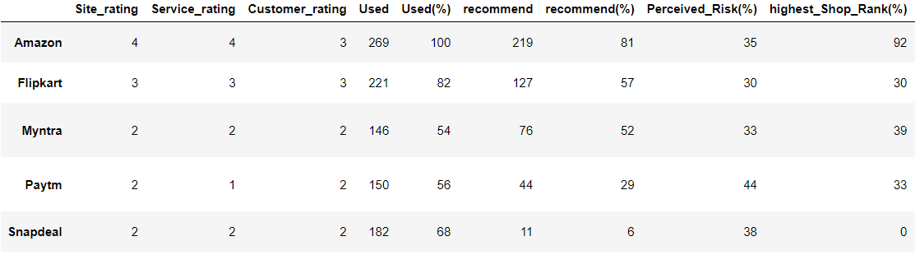

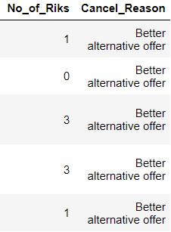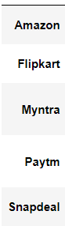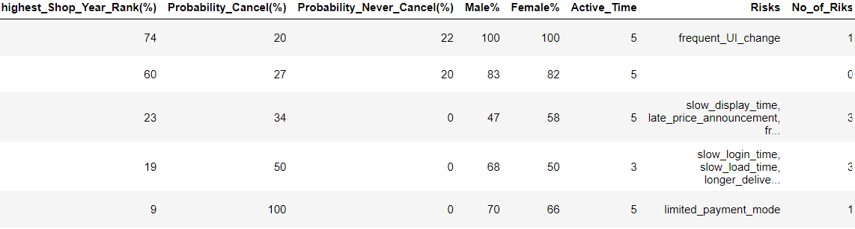

Use the above algo to find used%, recommended%, Risk%.

Finally we obtain the below dataset

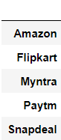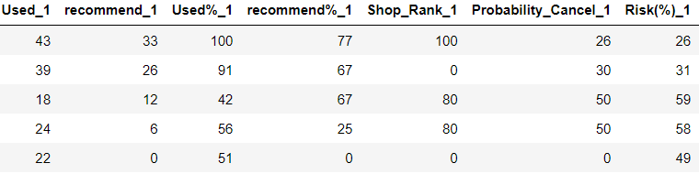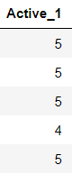

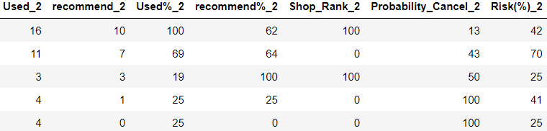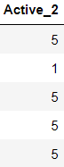

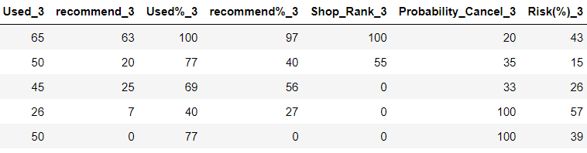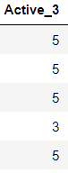

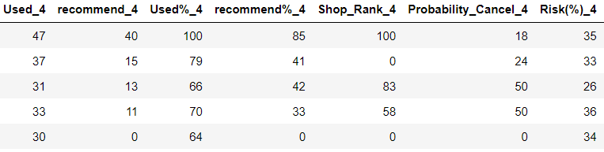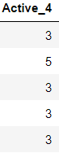

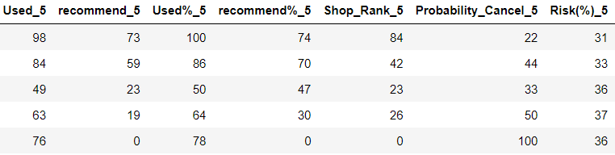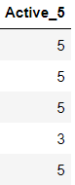

Graphical Representation of data:

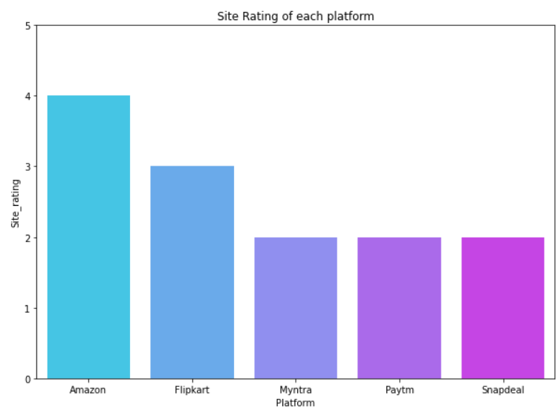

Insights:

* Site Rating is an imp factor for customer activation and retention.
* The higher the rating, the better the chances of retaining an existing user and grabbing the attention for new potential users.
* Amazon with an outstanding rating 4/5
* Flipkart next in line having rating 3/5
* The chances of customer activation and retention is higher in these platforms.
* Meanwhile the others have very lower chances of customer activation and higher chances of existing customers leaving based on the rating of their site.

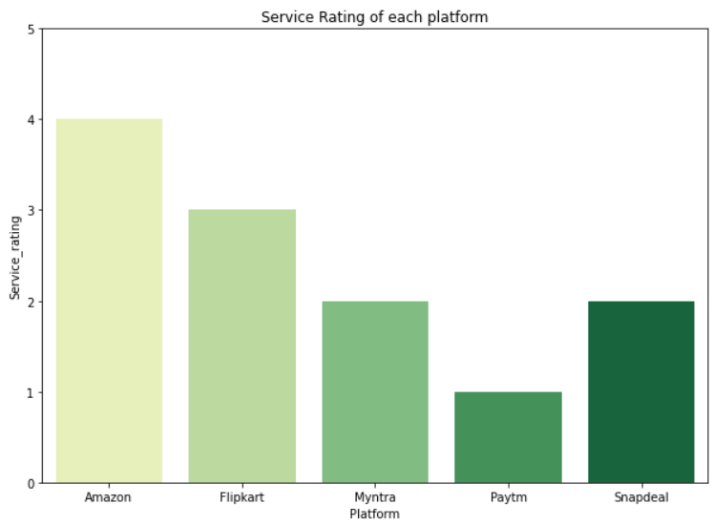

Insights:

* Service Rating is an imp factor for customer activation and retention
* The higher the rating, the better the chances of retaining an existing user and grabbing the attention for new potential users
* Amazon with an outstanding rating 4/5
* Flipkart next in line having rating 3/5
* The chances of customer activation and retention is higher in these platforms.
* Meanwhile the others have very lower chances of customer activation and higher chances of existing customers leaving based on the rating of their service. In specific Paytm is most likely to loose its existing customers

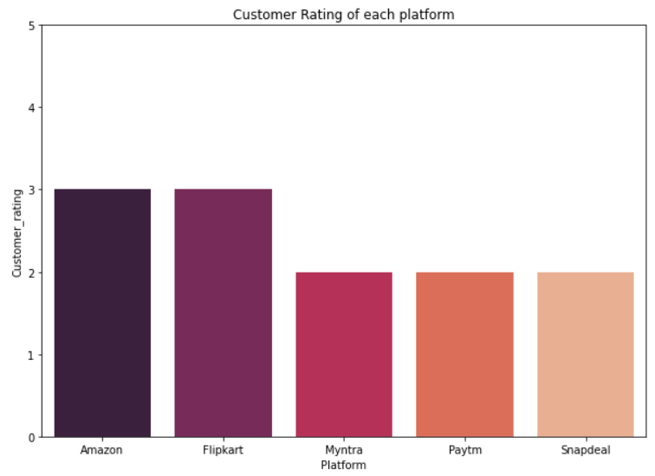

Insights:

* Customer Rating is an imp factor for customer activation and retention.
* It represents customer satisfaction of our platform, the higher the rating the more customers satisfied, hence retention and activation rate will see an increase in numbers
* The higher the rating, the better the chances of retaining an existing user and grabbing the attention for new potential users
* Amazon & Flipkart with a good rating 4/5
* the chances of customer activation and retention is higher in these platforms.
* meanwhile the others have very lower chances of customer activation and retention, higher chances of existing customers leaving based on the rating of their customers.

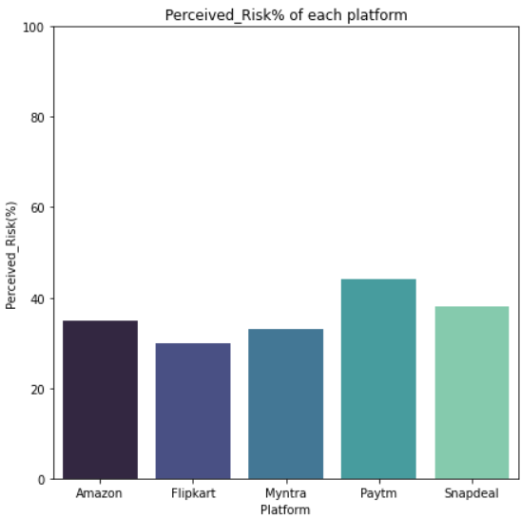

Insights:

* Perceived_Risk% is an imp factor for customer activation and retention
* The higher the risk%, the lower the chances of retaining an existing user and grabbing the attention for new potential users.
* If the risk% is of very value platform can start loose existing customers
* Flipkart has the lowest risk% among all of the platforms.
* Myntra being the second lowest and amazon third lowest.
* Myntra and amazon have almost similar risk%
* The chances of customer activation and retention is higher in these platforms.
* Meanwhile the others have very lower chances of customer activation and retention, higher chances of existing customers leaving based on the risk%.

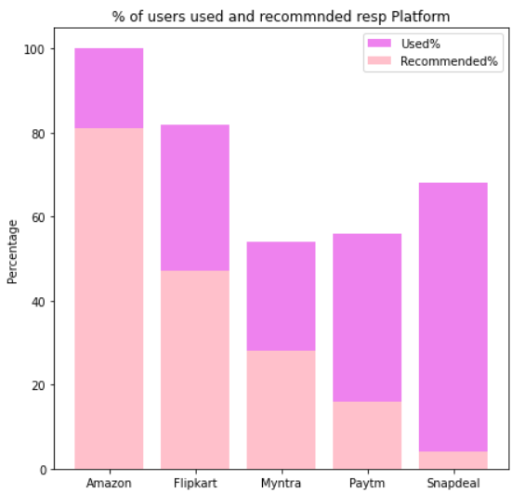

Insights:

* Amazon has highest used and recommended customers.
* Flipkart being next in line with high user% and recommendation%
* The chances of customer activation and retention is higher in these platforms.
* Meanwhile the others have very lower chances of customer activation and retention, higher chances of existing customers leaving based on the recommended%.
* Recommendation% is a sign of users interest in this platform, the higher, the more activation and retention

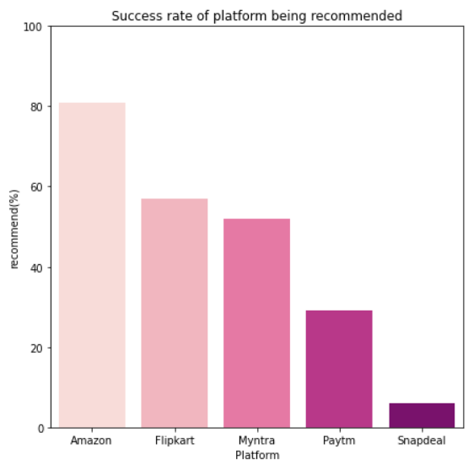

Insights:

* Success rate% is obtained by getting the percentage of users recommended out of the users used we get the success rate of each platform being recommended after usage.
* Success rate% is an imp factor for customer activation and retention.
* The higher the Success rate%, the higher the chances of retaining an existing user and grabbing the attention for new potential users.
* Amazon, Flipkart and Myntra have more than 50% success rate and hence the chances of customer activation and retention is higher in these platforms.

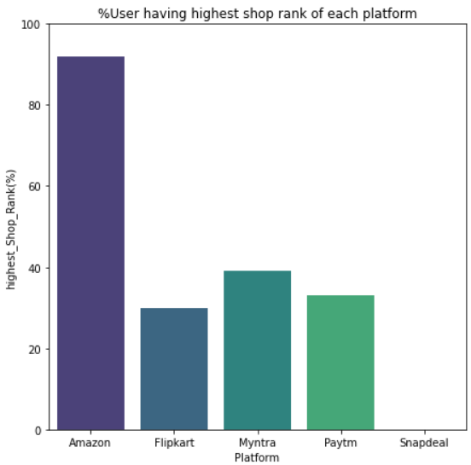

Insights:

* Out of the users which recommended this platform, what % of the users have highest shop rank.
* This shows the credibility of the user recommended.
* This is an imp factor for customer activation and retention.
* The higher the elite rank%, the higher the chances of retaining an existing user and grabbing the attention for new potential users.
* Amazon has an outstanding number of highest shop rank users, the chances for activation and retention of customer is very high.
* Rest don’t even have 50% of such grp in them.

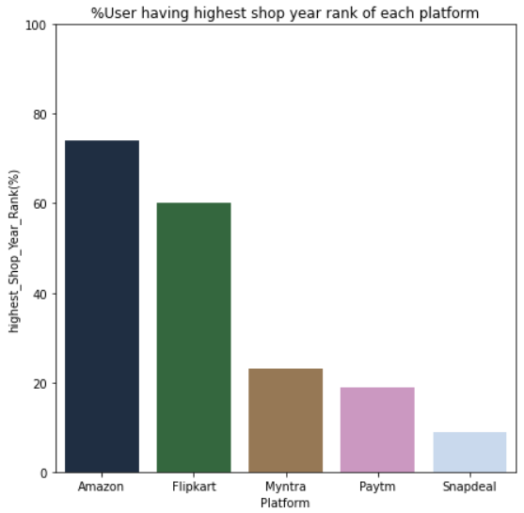

Insights:

* Out of the users which recommended this platform, what % of the users have highest shop year rank.
* This shows the credibility of the user recommended ,the higher the number the longer has the user used this platform and the recommended it.
* This is an imp factor for customer activation and retention
* The higher the elite rank%, the higher the chances of retaining an existing user and grabbing the attention for new potential users.
* Amazon & Flipkart has an outstanding number of highest shop year rank users, the chances for activation and retention of customer is very high.
* Rest don’t even have 50% of such group in them.

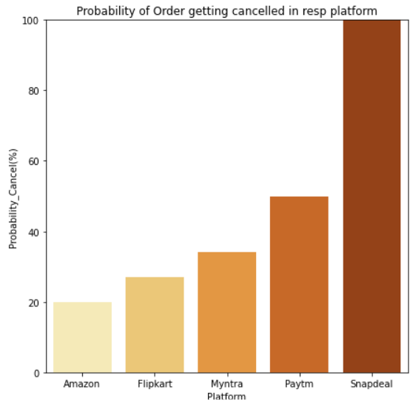

Insights:

* Cancel rate% is an important factor for customer retention
* The higher the Cancel rate%, the lower the chances of retaining an existing user. the increasing number also shows us the decreasing interest of a customer to buy from this platform.
* Amazon has the lowest cancel rate, then Flipkart and Myntra, rest all have more than 50% cancel rate and hence the chances of customer retention is lowest in these platforms
* The lower the cancel rate the better

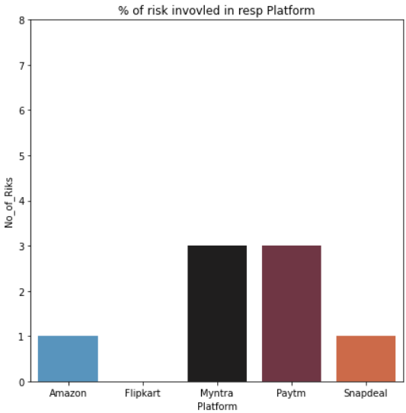

Insights:

* This graph gives us the number of drawbacks a platform has.
* The more the drawbacks the lower the chances of activation and retention of the customer.
* Flipkart being the one with no drawbacks and then Amazon and Snapdeal with one drawback
* The lesser the drawbacks, the better.
* Customer activation & Retention is inversely proportional to this number.

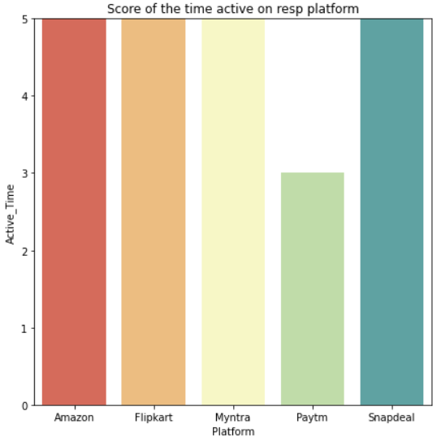

Insights:

* This graph gives us the time spent by a customer on the platform.
* The higher the number, the more the interest of a user to shop online from specified platform.
* Except for Paytm rest all have users spending most time for online shopping.
* The higher the number the more customer retention and more the activation.

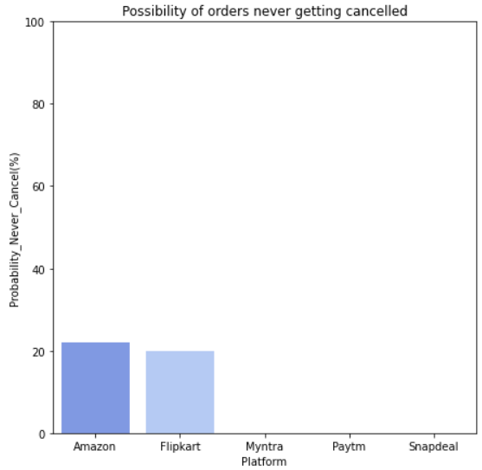

Insights:

* Possibility of an order never being cancel rate% is an imp factor to determine customer retention.
* The higher the percentage of Never Cancel rate%, the higher the chances of retaining an existing user.
* Amazon & Flipkart are the only platform where there are fair chances of the order might never get cancelled
* The higher the never cancel rate the better.

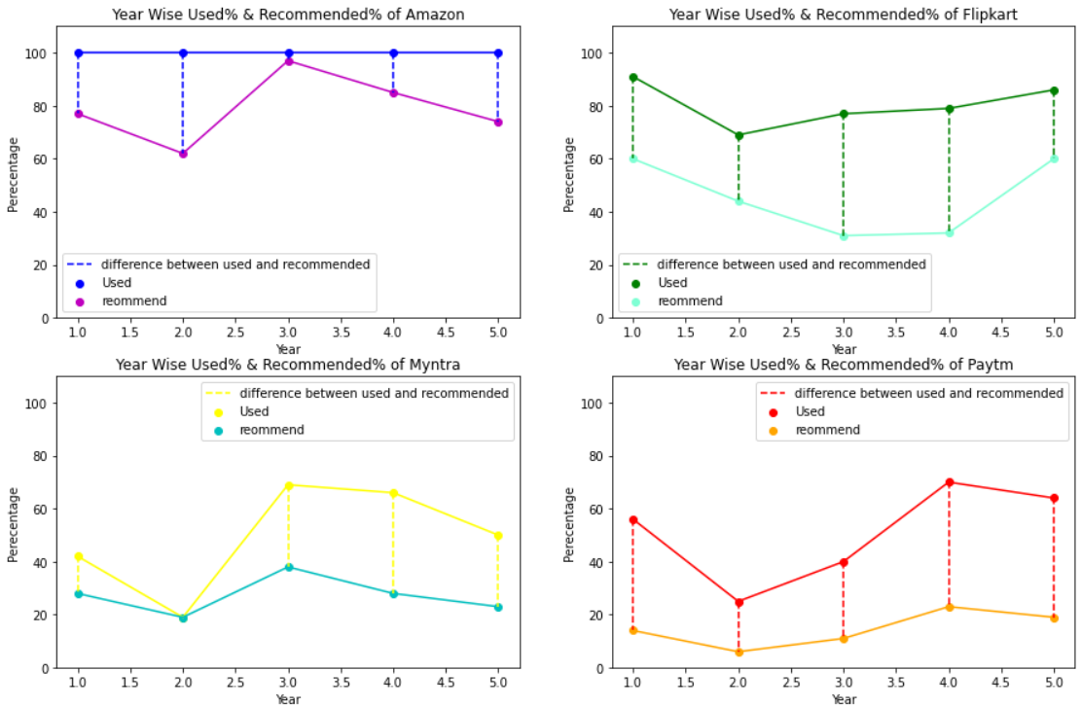

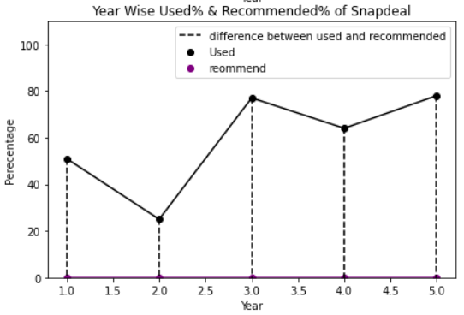

Insights:

* Year Wise Used% & Recommended% of every platform.
* From above graph we can check the % of users used the specific platform for every year rank and recommended the platform.
* We can deduce that as years progress how well is the customer retention and activation
* From above we can deduce that the users recommended for amazon is higher than the used% of users
* Hence the user activation of amazon is higher than any other platform.
* In this manner we can deduce users activation and retention of every platform year wise.
* To check retention we shall check the used and recommended % of every platform of year rank1 and year rank 5.
* Our goal should be to reduce the gap between the used% and recommended% of every platform, for better activation and retention.

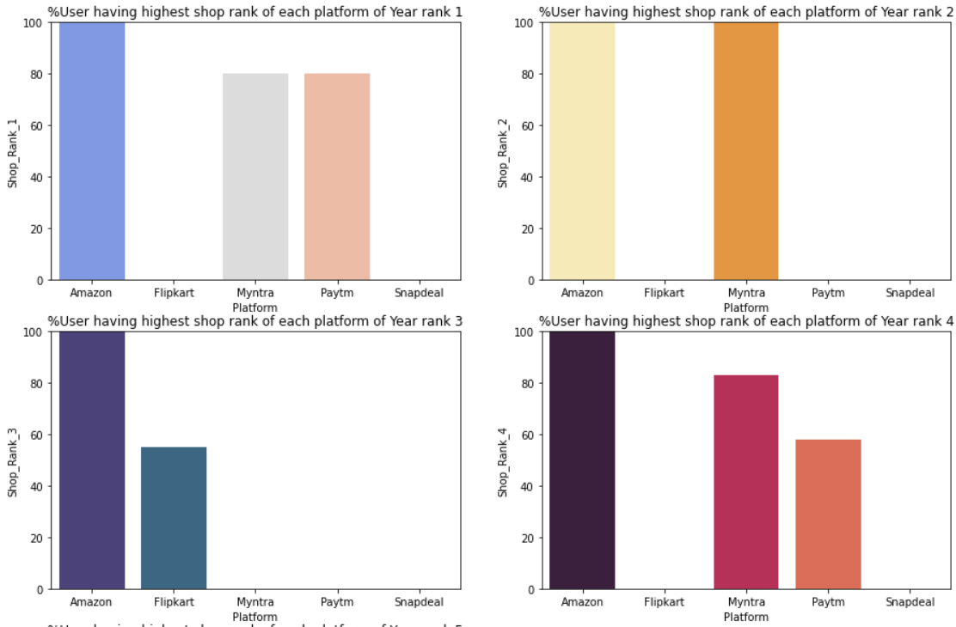

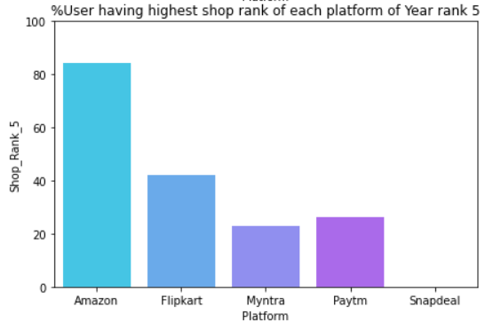

Insights:

Note: If platform value is blank that means during that year that platform was not used

* Year Wise % of User having highest shop rank of each platform
* Out of the users which recommended this platform. what % of the users have highest shop year rank.
* This shows the credibility of the user recommended
* This is an imp factor for customer activation and retention
* The higher the elite rank%, the higher the chances of retaining an existing user and grabbing the attention for new potential users.
* Year rank 1 has Amazon, Myntra, Paytm recommended more than 50%.
* Year rank 2 both Amazon and Myntra have all the users with highest year rank.
* Year rank 3 Amazon & Flipkart with more than 50%
* Year rank 4 all platforms cross 50% mark
* year rank 5 only amazon is able to cross 50% mark
* Meaning as the years goes on Amazon will be the platform with most activation and retention.
* Rest don’t even have 50% of such grp in them

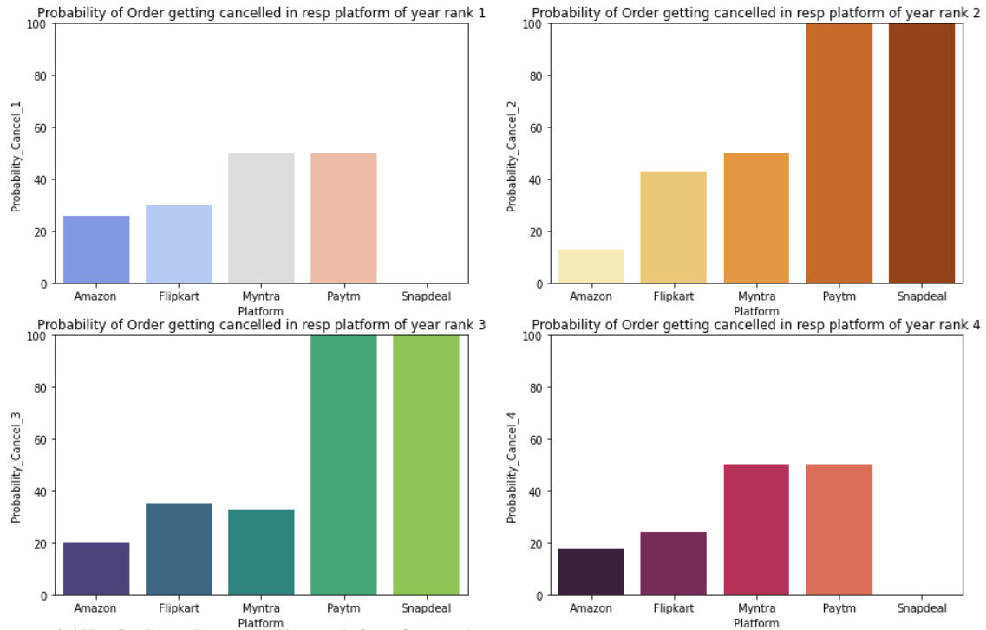

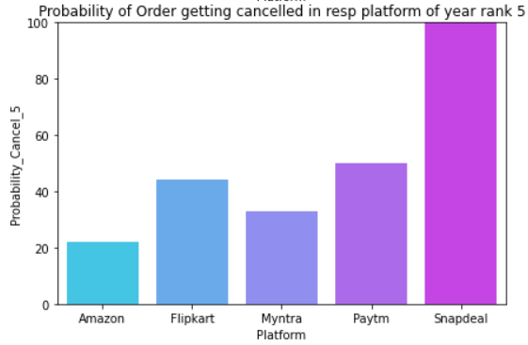

Insights:

Note: if platform value is blank that means during that year that platform was not used.

* Graph shows the Year Wise possibility of User cancelling the order
* Every year we can see that amazon has the lowest cancel ratio, then there is Flipkart and Myntra
* Paytm and Snapdeal have too much of cancel probability
* The lower the rate of cancellation the bigger the retention of a platform

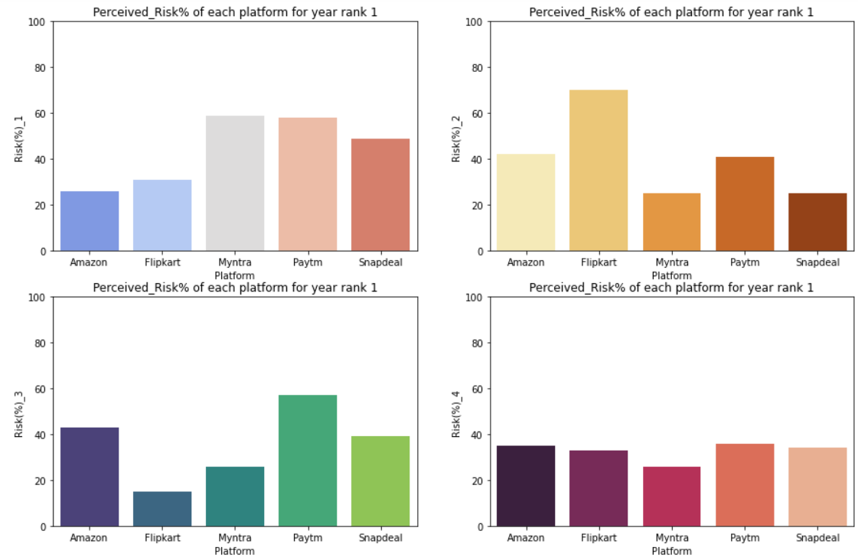

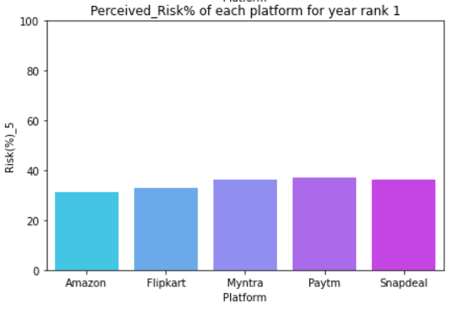

Insights:

* Graph shows the Year Wise %risk involved of an individual platform
* Year rank 1: Amazon and Flipkart have less than 40% risk
* Year rank 2: Myntra and Snapdeal have less than 40% risk
* Year rank 3; Myntra and Flipkart have less than 40%risk
* Year rank 4: all platforms have less than 40% risk
* Year rank 5: all platforms have less than 40% risk
* From above we can deduce that Myntra & Flipkart are the ones with lowest percentage of risk
* The lower the rate of risk the bigger the retention & activation of users of a platform

Analyze the data and find if a user has used all platforms what are his recommendations, his shopping rank (no of items bought in a year), cancel habit.

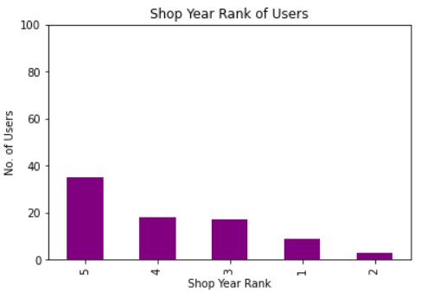

* The graph is to display shop year rank for a user who has used all the platforms available.
* Shop year rank of highest rank is attained when all platforms are used.
* Meaning when a user uses all the platforms, he will be continuing with online shopping for longer period of years.

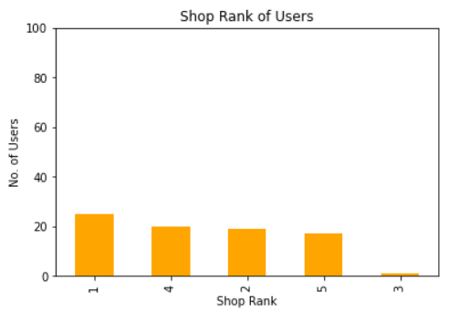

* The graph is to display shop rank for a user who has used all the platforms available.
* Lower shop rank is obtained when a user uses all platform.

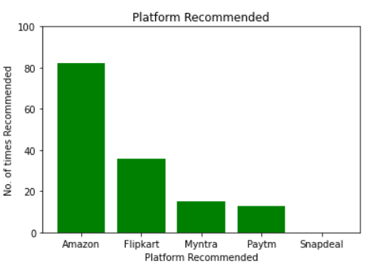

* We can see that when user has used all the platform, he is never recommending Snapdeal.
* Amazon & Flipkart are most recommended.

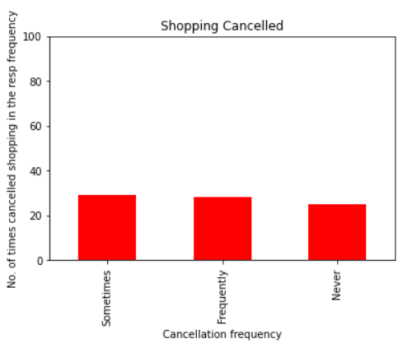

* When a User uses all the platform his cancellation frequency also decreases.
* Good chance of an order never being cancelled or being cancelled very few times.
* In comparison to the combination of never and sometimes cancellation frequency, frequent shopping cancellation is less.

**Conclusion**

* Amazon and Flipkart are most used and recommended platforms.
* These platforms have higher rating in every terms.
* These platforms have lower risk%, lesser drawbacks and less cancellation chances of an order.
* These platforms have high percentage of elite group with good credibility using and recommending the platform.
* Out of these 2, Amazon is the one which has higher chances of customer activation and recommendation.
* Rest all platforms should be improved or their existing users are going their platforms.